Alerting and Monitoring

For alarming mechanism regarding any issue in Application, we can use APM (Application performance monitoring tool) like AppDynamics, Splunk etc.
Case-1:
AppDynamics:
Using Appdynamics we can monitor our application and as well infrastructure. It provide end to end monitoring solution.
Appdynamics Components:
- Controller
- Agents
- Event Controller
- Database

Controller is the main component of AppDynamics as it is responsible for processing of metrics related to application, infrastructure, database etc. in human readable format like numbers and graphs which is easy to interpret and understand.
Controller can be on-premise and on-cloud(Saas).
Screenshot of Appdynamics controller UI

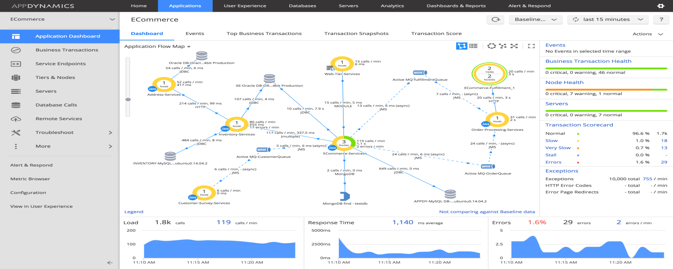
Agents:
Agents are deployed application level in case we are using app agent (like java agent for Java application, .Net agent for .Net application depending on the framework of the application). When agent is deployed it binds itself with the application process and do a byte code injection as soon the application process start. Start collecting the metrics like Load, HTTP errors, response time, garbage collection time, heap consumption, jvm cpu ,business transactions etc.
These metrics are sent to the controller and controller interpret these metrics and show it in the form of numbers and graphs which is easy to understand

Events Service:
Now when the metrics are collected by agent and reported back to the controller health rule can be setup with threshold value for warning and critical situation based on the metrics like response time of application, load, major GC time, application availability etc.
These health rules are mapped with the policy so that whenever health rule got violated it will trigger email or x-matter based on the policy setup.
Event service is responsible for storing all type of health rule violation.

